How to Install Discount Package
DISCOUNT PACKAGE for Microsoft CRM
Published: May 4, 2014

Contents
1 Overview 3
2 CRM Discount Package Custom Entities 4
2.1 Description of Custom Entities in Discount Package 4
2.1.1 Customer Discount Group 4
2.1.2 Product Discount Group 4
2.1.3 SalesHeaderDiscount 4
2.1.4 SalesLinesDiscount 6
2.2 Import New Custom Entities to Microsoft CRM 3.0 10
3 Manual Customization 12
3.1 Customizations of System Entities 12
3.1.1 Account 12
3.1.2 Product 13
3.1.3 Quote 14
3.1.4 Quote Product 17
3.2 Configuration Customization 23
3.2.1 ISV Config 23
3.3 Finalization 24
4 Automatic Customization: CRM Discount Package Installation Program 25
4.1 Preparation for CRM Discount Package Automatic Setup 25
4.2 Description of CRM Discount Package Installation Program 26
4.2.1 Automatic Installation 27
4.2.2 Additional Installation Tasks 30
4.3 Post-Installation Verification 34

Overview
This document describes how to set up the customizations provided by CRM Discount Package for Microsoft CRM in an existing Microsoft CRM 3.0 system.

- Manual installation is described in 2 Discount Package Custom Entities and in 3 Manual Customization. It includes the following stages:

  - Import new custom entities:

- SalesLinesDiscount
- SalesHeaderDiscount
- ProductDiscountGroup
- CustomerDiscountGroup

There are two ways of the manual installation:
- import and publish the customizations file (Setup\Customizations\new_entities_customizations.xml)
- create them manually (chapter 2)

  - Correct existing entities (chapter 3):

- Account
- Product
- Quote
- QuoteDetail

All custom attributes must have “new_” prefix.

Before making any customization in Microsoft CRM, we highly recommend that you save both the METABASE and MSCRM databases of Microsoft CRM.

The description part of each entity only consists of fields that participate in calculations.

After having made all changes (importing new entities and correcting the system), you must publish the modified entities and in the design mode check the Settings, Sales, Workplace check boxes within the Areas that displays entity group box.

- Automatic installation is described in 4 Automatic Customization: Discount Package Installation .

Post-update changes: correct codes of all new entities using the setup program: Setup\ WinDiscountSetup.exe

Discount Package Custom Entities

Description of Custom Entities in Discount Package
The following few section contain descriptions of all custom entities from the Discount Package.

Customer Discount Group

Description
This is a custom entity to denote customers with the same privileges on discounts – CustomerDiscountGroup.

- Ownership: User
- Related Entities: Account, Sales Lines Discount
- Show in Microsoft CRM client for Outlook when offline: Yes
- Areas that display this entity: Settings

Schema Name | Type | Comments | Description
new_name | Nvarchar (100) | New schema field | Name
Table 1 – Created or modified attributes (Customer Discount Group)

Product Discount Group

Description
This is a custom entity to denote products to be used for one or another discount – ProductDiscountGroup.

- Ownership: User
- Related Entities: Product, Sales Lines Discount
- Show in Microsoft CRM client for Outlook when offline: Yes
- Areas that display this entity: Settings

Schema Name | Type | Comments | Description
New_name | Nvarchar (100) | New schema field | Name
Table 2 – Created or modified attributes (Product Discount Group)

SalesHeaderDiscount

Description
This is a custom entity to denote a discount (%) on certain amount (money) for the account on a whole quote.

- Ownership: User
- Related Entities: Quote, Account
- Show in Microsoft CRM client for Outlook when offline: yes
- Areas that display this entity: Sales, Workspace, Settings

Schema Name | Type | Comments | Description
New_name | Nvarchar (100) | New schema field | Name
New_parentaccountid | Lookup | New schema field  Lookup to parent Account Entity | Parent Account
New_minimumamount | Money | New schema field | Minimum Amount to use discount
New_minimumquantity | Float | New schema field | Minimum Quantity, when it is possible to use discount
New_discountpercents | Float | New schema field | Discount, %
Table 3 – Created or modified attributes (Sales Header Discount)
New_parentaccountid: the result of adding a relationship between Account (Primary Entity) and SalesHeaderDiscount (Related Entity):

- Attribute name: Parent Account
- Type of behavior: Referential

Approximate View
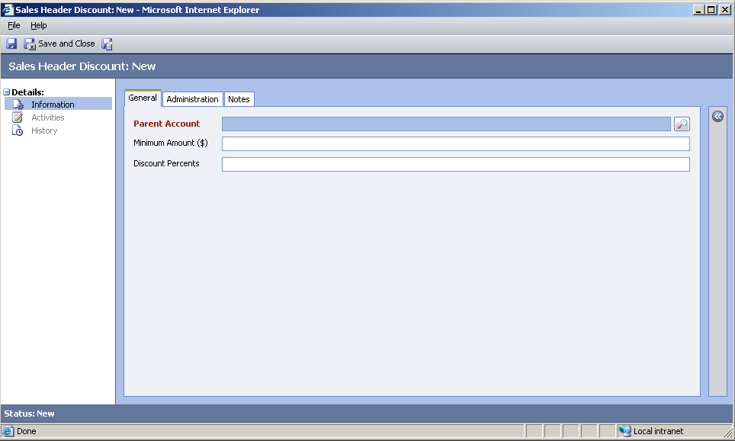
Figure 1 - Approximate view of SalesHeaderDiscount Form
If you create a new header, you must:

- choose an Account for which the discount is available
- fill the Minimum Amount and Discount Percents fields

SalesLinesDiscount

Description
This is a custom entity to denote discount (%) on a minimum quantity of a certain product, included into the account quote.

Ownership: User
Related Entities: Account, Customer Discount Group, Quote Product, Product Discount Group
Show in Microsoft CRM client for Outlook when offline: Yes
Areas that display this entity: Sales, Settings, Workplace

Schema Name | Type | Comments | Description
New_name | nvarchar (100) | New schema field | Name
New_uomname | nvarchar (100) | New schema field | UOM
New_startingdate | datetime | New schema field | Starting Discount Date
New_endingdate | datetime | New schema field | Ending Discount Date
New_parentaccountid | lookup | New schema field  Lookup to parent  Account Entity | Related Account
New_customerdiscountgroupid | lookup | New schema field | Customer Discount Group
New_customergroupflag | bit (1) | New schema field | Flag shows is discount for certain customer or for all Customer Discount Group
New_linediscountpercents | float | New schema field | Line Discount, %
New_minimumquantity | float | New schema field | Minimum Quantity, when it is possible to use discount
New_relatedproductid | lookup | New schema field  Lookup to parent  Product Entity | Related Product
New_productdiscountgroupid | lookup | New schema field | Product Discount Group
New_productgroupflag | bit (1) | New schema field | Flag shows is discount used for certain product or for all Product Discount Group
Table 4 - Created or modified attributes (Sales Header Discount)

New Fields
New_parentaccountid: the result of adding a relationship between Account (Primary Entity) and SalesLinesDiscount (Related Entity):

- Attribute name: Parent Account
- Type of behavior: Referential

New_customerdiscountgroupid: the result of adding relationship between CustomerDiscountGroup (Primary Entity) and SalesLinesDiscount (Related Entity):

- Attribute name: Customer Discount Group
- Type of behavior: Referential

New_relatedproductid: the result of adding relationship between Product (Primary Entity) and SalesLinesDiscount (Related Entity):

- Attribute name: “Related Product”
- Type of behavior: Referential

New_productdiscountgroupid: the result of adding relationship between ProductDiscountGroup (Primary Entity) and SalesLinesDiscount (Related Entity):

- Attribute name: “Product Discount Group”
- Type of behavior: Referential

Views and the Form
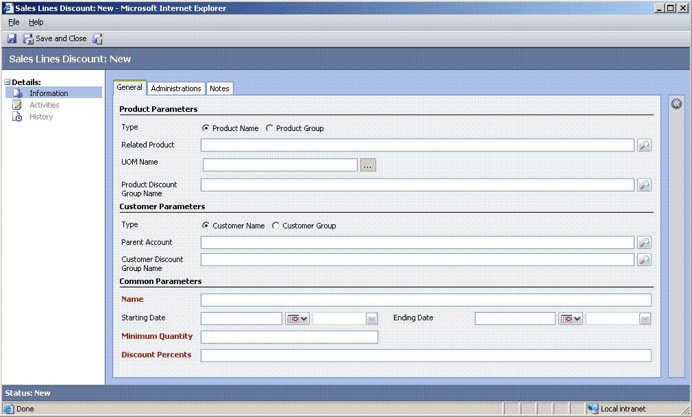
Figure 2 - Approximate view of SalesLinesDiscount Form
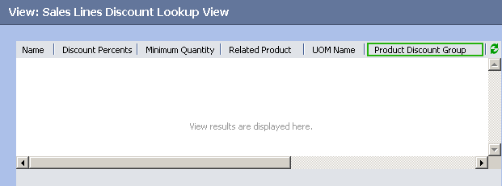
Figure 3 - Example of Lookup View of SalesLinesDiscount (Part 1)
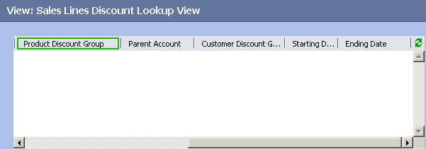
Figure 4 - Example of Lookup View of SalesLinesDiscount (Part 2)

Events
The OnLoad event of SalesLinesDiscount Form must be enabled and the following script must be added:

//1__ Draw button to call _____LOOKUP UOM______

var uomFld = document.getElementById("new_uomname");
if(uomFld != null)
uomFld.outerHTML =
'<table width=\"100%\"><tr> <td width=\"90%\" >'
+ uomFld.outerHTML
+'</td> <td><input type=button value=\"...\" name=\"uom_viewer\" ></td></tr></table>';

var returnVal = "";
var url = '/_controls/lookup/lookupsingle.aspx?objecttypes=1055&browse=0';

if(document.getElementById("uom_viewer") != null)
{
document.getElementById("uom_viewer").onclick = function()
{
returnVal = window.showModalDialog(url);
if(returnVal != null)
crmForm.all.new_uomname.value =
returnVal.items[0].keyValues["name"].value;
}
}

//2___ENABLED - DISABLED product/ customer fields

var productGroupFlag = crmForm.all.new_productgroupflag;
if(productGroupFlag != null)
{
if(crmForm.FormType == 1)
crmForm.all.new_productgroupflag.DataValue = true;

if(crmForm.all.new_productdiscountgroupid != null)
{
if(crmForm.all.new_productgroupflag.DataValue)
{
crmForm.all.new_relatedproductid.disabled= false;
crmForm.all.new_productdiscountgroupid.disabled =true;
crmForm.all.new_productdiscountgroupid.DataValue = null;
}
else
{
crmForm.all.new_relatedproductid.disabled = true;
crmForm.all.new_productdiscountgroupid.disabled = false;
crmForm.all.new_relatedproductid.DataValue = null;
}
}

}

var customerGroupFlag = crmForm.all.new_customergroupflag;

if(customerGroupFlag != null)
{
if(crmForm.FormType == 1)
crmForm.all.new_customergroupflag.DataValue = true;

if(crmForm.all.new_customerdiscountgroupid != null)
{
if (customerGroupFlag.DataValue)
{
crmForm.all.new_parentaccountid.disabled= false;
crmForm.all.new_customerdiscountgroupid.disabled =true;
crmForm.all.new_customerdiscountgroupid.DataValue = null;
}
else
{
crmForm.all.new_parentaccountid.disabled= true;
crmForm.all.new_customerdiscountgroupid.disabled =false;
crmForm.all.new_parentaccountid.DataValue = null;
}
}

}
Listing 1 – Script to add to OnLoad
The OnSave event of SalesLinesDiscount Form must be enabled and the next script must be added:

if(((crmForm.all.new_parentaccountid == null)
||(crmForm.all.new_parentaccountid.DataValue == null))
&& ((crmForm.all.new_customerdiscountgroupid == null)
||(crmForm.all.new_customerdiscountgroupid.DataValue == null)))
{
alert("Enter Customer information !");
event.returnValue=false;
}

if (((crmForm.all.new_relatedproductid == null)
||(crmForm.all.new_relatedproductid.DataValue == null))
&&((crmForm.all.new_productdiscountgroupid == null)
||(crmForm.all.new_productdiscountgroupid.DataValue== null)))
{
alert("Enter Product information !");
event.returnValue=false;
}
Listing 2 – Script to add to OnSave
The New_customergroupflag field must be added to the Form (by checking the proper check box) and the OnChange event for it must be enabled and look as follows:

var customerGroupFlag = crmForm.all.new_customergroupflag;
if(customerGroupFlag != null)
{
if (customerGroupFlag.DataValue)
{
crmForm.all.new_parentaccountid.disabled= false;
crmForm.all.new_customerdiscountgroupid.disabled =true;
crmForm.all.new_customerdiscountgroupid.DataValue = null;
}
else
{
crmForm.all.new_parentaccountid.disabled= true;
crmForm.all.new_customerdiscountgroupid.disabled =false;
crmForm.all.new_parentaccountid.DataValue = null;
}
}
Listing 3 – Script for OnChange (New_customergroupflag)
Also, the new_productgroupflag field must be added to the Form and the OnChange event for it must be enabled and look as follows:

var productGroupFlag = crmForm.all.new_productgroupflag;
if(productGroupFlag != null)
{
if (crmForm.all.new_productgroupflag.DataValue)
{
crmForm.all.new_relatedproductid.disabled= false;
crmForm.all.new_productdiscountgroupid.disabled =true;
crmForm.all.new_productdiscountgroupid.DataValue = null;
}
else
{
crmForm.all.new_relatedproductid.disabled= true;
crmForm.all.new_productdiscountgroupid.disabled =false;
crmForm.all.new_relatedproductid.DataValue = null;
}
}
Listing 4 – Script for OnChange (new_productgroupflag)

Import New Custom Entities to Microsoft CRM 3.0

- There are two ways to create new entities:

  - create them manually as was described above (see 2.1.1 Customer Discount Group through 2.1.4 SalesLinesDiscount)
  - import the new_entities_customization.xml file(see 4.1 Preparation for Discount Package Automatic Setup)

- After having imported to, or created new entities in Microsoft CRM 3.0 (on the server):

  - publish all of them
  - in the design mode for each of them, check the Settings, Sales, Workplace check boxes within the Areas that displays this entity group box
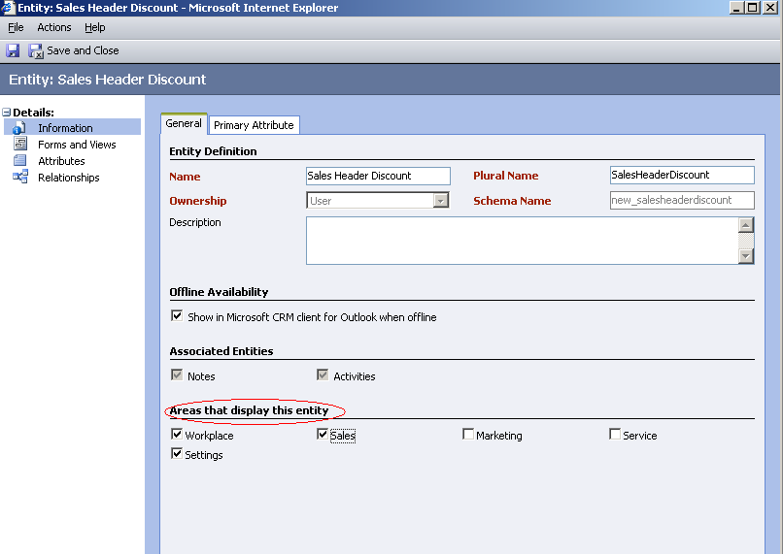
Figure 5 – Settings, Sales and Workplace checkboxes selected

Manual Customization

Customizations of System Entities

Account

Description
Schema Name | Type | Comments | Description
New_customerdiscountgroupid | lookup | New schema field. | Customer Discount Group
Table 5 – Created or modified attributes (Account)

New Fields
New_customerdiscountgroupid appears after adding relationship between Account (Primary Entity) and Customer Discount Group (Related Entity):

Attribute name: Parent Account
Type of behavior: Referential

Form
Add the New_customerdiscountgroupid field with the Customer Discount Group Name label as shown below:
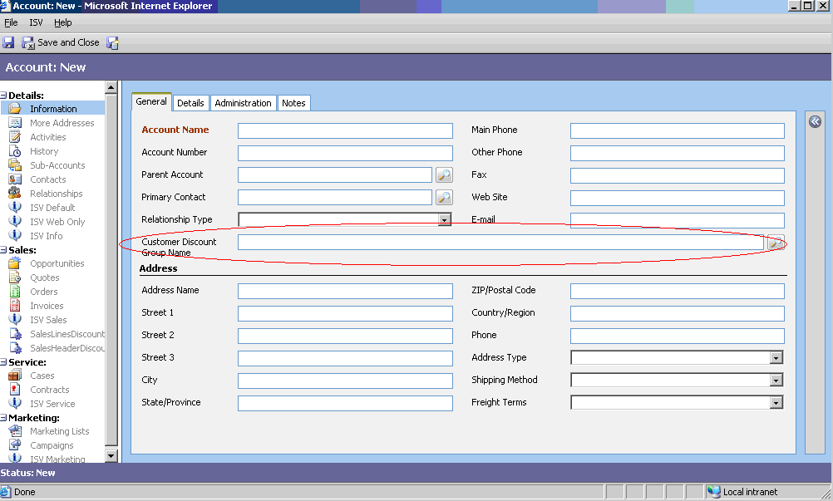
Figure 6 - Approximate view of Account Form

Events
The OnLoad event of Account Form must be enabled and the following script must be added:

// ___Discount Package 3.0___
//Detect CustomerDiscountGroup for 'Quote Product' form from IFrame_Account

if((window.frameElement != null) &&(window.frameElement.document!= null))
{
if( (window.frameElement.document.getElementById("new_customergroup")!= null)
&&(document.getElementById("new_customerdiscountgroupid")!= null)
&&(document.getElementById("new_customerdiscountgroupid").DataValue != null))
window.frameElement.document.getElementById("new_customergroup").value = document.getElementById("new_customerdiscountgroupid").DataValue[0].id;

}

Listing 5 – Script to add to OnLoad

Product

Description
Schema Name | Type | Comments | Description
New_productdiscountgroupid | lookup | New schema field. | Product Discount Group
Table 6 - Created or modified attributes (Product)

New Fields
New_productdiscountgroupid appears after adding a relationship between Product (Primary Entity) and Product Discount Group (Related Entity):

- Attribute name: Related Product
- Type of behavior: Referential

Form
Add the New_productdiscountgroupid field with the Product Discount Group Name label as shown below:
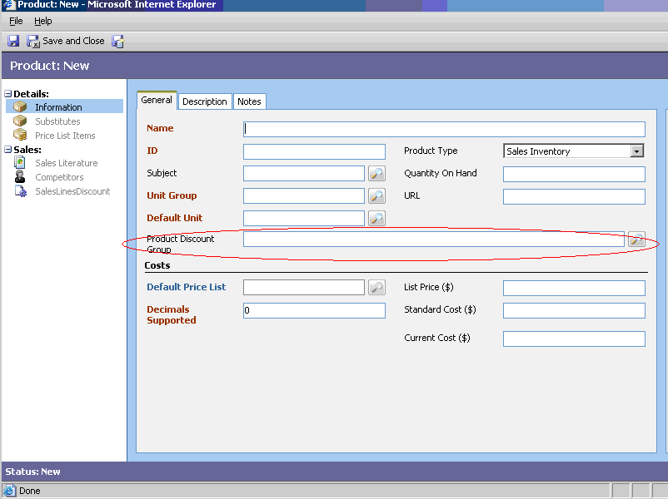
Figure 7 - Approximate view of Product Form

Events
The OnLoad event of the Product Form must be enabled and the following script must be added:

// ___Discount Package 3.0___
//___Detect customer accountid for quotedetail form from IFrame_Quote
if((window.frameElement != null) &&(window.frameElement.document!= null))
{
if((window.frameElement.document.getElementById("new_productgroup")!= null)
&&(document.getElementById("new_productdiscountgroupid")!= null)
&&(document.getElementById("new_productdiscountgroupid").DataValue!= null))
window.frameElement.document.getElementById("new_productgroup").value =
document.getElementById("new_productdiscountgroupid").DataValue[0].id;
}
Listing 6 – Script to add to OnLoad

Quote

Description
Schema Name | Type | Comments | Description
discount percentage | float |  | Discount, %
Table 7 – Created or modified attributes (Quote)

Events
The OnSave event of Quote Form must be enabled and script must be added:

// ___Discount Package 3.0___
//1_____Detect customer accountid for quotedetail form from IFrame_Quote

if((window.frameElement != null) &&(window.frameElement.document!= null))
{
if((window.frameElement.document.getElementById("new_parentaccount")!= null) &&(document.getElementById("customerid")!= null))
window.frameElement.document.getElementById("new_parentaccount").value = document.getElementById("customerid").DataValue[0].id;

//Load account info to quotedetail
if(window.frameElement.document.getElementById("IFRAME_Account")!= null)
{
var accountUrl = "/_forms/readonly/readonly.aspx?objTypeCode=1&id="+crmForm.all.customerid.DataValue[0].id;
window.frameElement.document.getElementById("IFRAME_Account").src = accountUrl;
}

}

//2___ Get FetchXML function to filter 'Sales Header Discount' lookup
function GetFetchXML(account, detailamount)
{
var filterSTR =
"<filter type='and'>"
+ "<filter type='or'>"
+ "<condition attribute='new_parentaccountid' operator='eq' value='" + account + "'/>"
+ "<condition attribute='new_parentaccountid' operator='null' />"
+ "</filter>";

if (detailamount> 0)
{
filterSTR += "<filter type='or'>"
+ "<condition attribute='new_minimumamount' operator='le' value='" + detailamount +"'/>"
+ "</filter>";
}

filterSTR += "</filter>";

var additionalparams =
"<fetch mapping='logical'>"
+ "<entity name='new_salesheaderdiscount'>"
+ "<all-attributes/>"
+ filterSTR
+"</entity>"
+"</fetch>";

return additionalparams;
}

//3_____ Function to load LookUp for ToolBarButton 'Header Discount...' OnClick event

document.body.ShowLookUp = function()
{
if(crmForm.all.customerid.DataValue == null)
{
alert("Provide a value for Potential Customer!");
}
else if ((crmForm.all.customerid.DataValue[0] != null)
&&(typeof(crmForm.all.customerid.DataValue[0]) != "undefined"))
{
if (typeof(crmForm.all.customerid.DataValue[0].name) != "undefined")
{
var ___SalesHeaderDiscountCode = 10000;
var account = crmForm.all.customerid.DataValue[0].id;
var detailamount=
crmForm.all.totallineitemamount.value.replace(ORG_CURRENCY_SYMBOL,"");
detailamount=(detailamount.length == 0)?0:LocStringToFloat(detailamount);

var fetchXml = GetFetchXML(account, detailamount);
var url = "/_controls/lookup/lookupsingle.aspx?objecttypes=" +
___SalesHeaderDiscountCode + "&browse=1" + "&fetchXml=" + fetchXml;

var returnValue = window.showModalDialog(url);
if (returnValue != null)
{
var discountpercents =
returnValue.items[0].keyValues["new_discountpercents"].value;
var minam = returnValue.items[0].keyValues["new_minimumamount"].value.replace(ORG_CURRENCY_SYMBOL,"");
var minamount = (minam.length == 0)? 0: LocStringToFloat(minam);

if(detailamount > minamount)
{
if (confirm("Apply discount?" ,"Yes", "No"))
{
crmForm.all.discountpercentage.DataValue = LocStringToFloat(discountpercents) ;
alert("Total Amount($) value is not recalculated yet. Click Save/Recalculate!");

}
}
else
{
var mess =
"Discount is unavailable: Detail Amount($) is less than "
+ minam +" " + ORG_CURRENCY_SYMBOL + " !";
alert(mess);
}

}
}
}
};
Listing 7 – Script to add to OnSave
Replace the highlighted code (var ___SalesHeaderDiscountCode = 10000;) with the code of SalesLinesDiscount entity:

- Open the <our_business_unit>_METABASE database (Microsoft SQL Server) and then the Entity table
- Find the line for the entity with the Name=”New_SalesHeaderDiscount”
- Get the value for the [ObjectTypeCode] column

Alternatively, use the Discount Package installation program as shown in 4.2.2.2 Get ObjectTypesCode of Custom Entity.

Quote Product

Description
Schema Name | Type | Comments | Description
baseamount | money |  | Purchase amount, money
manualdiscountamount | money | New schema field | Discount, money
new_manualdiscountpercents | float | New schema field | Discount, %
new_parentaccount | nvarchar | New schema field | Account for discount
new_customergroup | nvarchar | New schema field | Customer Discount Group
new_productgroup | nvarchar | New schema field | Product Discount Group
Table 8 – Created or modified attributes (Quote Product)

New Fields

New_manualdiscountpercents – discount (%, for a quote product) established by a manager

New_parentaccount – account, for which a quote discount will be available

New_customergroup – Customer Discount Group

New_productgroup – Product Discount Group

Events

- The OnLoad event of Quote Product Form must be enabled and the following script must be added:

// ___Discount Package 3.0___
//1___Hide additional fields with product information

if(crmForm.all.IFRAME_Account != null)
crmForm.all.IFRAME_Account.style.visibility = 'hidden';
if(crmForm.all.IFRAME_Quote != null)
crmForm.all.IFRAME_Quote.style.visibility = 'hidden';
if(crmForm.all.IFRAME_Product != null)
crmForm.all.IFRAME_Product.style.visibility = 'hidden';
if(crmForm.all.new_productgroup != null)
crmForm.all.new_productgroup.style.visibility = 'hidden';
if(crmForm.all.new_customergroup != null)
crmForm.all.new_customergroup.style.visibility = 'hidden';
if(crmForm.all.new_parentaccount != null)
crmForm.all.new_parentaccount.style.visibility = 'hidden';

//2___ Get FetchXML function to filter 'Sales Lines Discount' lookup

function GetFetchXML(account, productid, uomid, quantity, nowDT)
{
var filterSTR =
"<filter type='and'>"
+ "<filter type='or'>"
+ "<condition attribute='new_parentaccountid' operator='eq' value='" + account + "'/>"
+ "<condition attribute='new_customerdiscountgroupid' operator='eq' value='" + crmForm.all.new_customergroup.value + "'/>"
+ "</filter>"
+ "<filter type='or'>"
+ "<condition attribute='new_relatedproductid' operator='eq' value='" + productid +"'/>"
+ "<condition attribute='new_productdiscountgroupid' operator='eq' value='" + crmForm.all.new_productgroup.value + "'/>"
+ "</filter>";

if(uomid != null)
{
filterSTR +=
"<filter type='or'>"
+ "<condition attribute='new_uomname' operator='eq' value='"+ uomid +"'/>"
+ "<condition attribute='new_uomname' operator='null' />"
+ "</filter>";
}

filterSTR +=
"<filter type='or'>"
+ "<condition attribute='new_startingdate' operator='le' value='" + nowDT +"'/>"
+ "<condition attribute='new_startingdate' operator='null' />"
+ "</filter>"
+ "<filter type='or'>"
+ "<condition attribute='new_endingdate' operator='ge' value='" + nowDT +"'/>"
+ "<condition attribute='new_endingdate' operator='null' />"
+ "</filter>" ;

if (quantity > 0) //crmForm.FormType == UpdateFormType
{
filterSTR +=
"<filter type='or'>"
+ "<condition attribute='new_minimumquantity' operator='le' value='" + quantity +"'/>"
+ "</filter>";
}
filterSTR += "</filter>";

var additionalparams =
"<fetch mapping='logical'>"
+ "<entity name='new_saleslinesdiscount'>"
+ "<all-attributes/>"
+ filterSTR
+"</entity>"
+"</fetch>";

return additionalparams;
}

//3____LOOKUP FOR "SALES LINES DISCOUNT" called by onClick event of toolbar button "LINES DISCOUNTS..."

//3.1___ Fill IFrame_Quote with quote information. Quote onLoad method fills accountid field
if((crmForm.all.IFRAME_Quote != null)&&(crmForm.all.quoteid != null)&&(crmForm.all.quoteid.value!= null))
{
var quoteUrl = "/_forms/readonly/readonly.aspx?objTypeCode=1084&id="+crmForm.all.quoteid.value;
crmForm.all.IFRAME_Quote.src = quoteUrl;
}

//3.2___ Fill IFrame_Product with product information
if((crmForm.all.IFRAME_Product != null)&&(crmForm.all.productid != null)&&(crmForm.all.productid.DataValue != null))
{
var productUrl = "/_forms/readonly/readonly.aspx?objTypeCode=1024&id="+crmForm.all.productid.DataValue[0].id;
crmForm.all.IFRAME_Product.src = productUrl;
}

//3.3
document.body.ShowLookUp = function()
{
if ((crmForm.all.productid.DataValue == null) || (typeof(crmForm.all.productid.DataValue[0]) == "undefined"))
{
alert("You must provide a value for Product !");
}
else if ((typeof(crmForm.all.productid.DataValue[0]) != "undefined")&& (typeof(crmForm.all.productid.DataValue[0].name) != "undefined"))
{
var ___LinesDiscountCode = 10001;
var amount = crmForm.all.baseamount.value.replace(ORG_CURRENCY_SYMBOL,"");
amount = (amount.length == 0)?0: LocStringToFloat(amount);

//Build FetchXML
var quantity = (crmForm.all.quantity.value.length == 0)? 0:LocStringToFloat(crmForm.all.quantity.value);
var account = crmForm.all.new_parentaccount.value;
var productid = (crmForm.all.productid.DataValue == null)? null :crmForm.all.productid.DataValue[0].id;
var uomid = (crmForm.all.uomid.DataValue == null)? null :crmForm.all.uomid.DataValue[0].name;
var nowDT = LocalDateTimeNow();
var nowDTFormat = FormatDateTime(nowDT);

var addParams = GetFetchXML(account, productid, uomid, quantity, nowDTFormat);
var url = "/_controls/lookup/lookupsingle.aspx?objecttypes=" + ___LinesDiscountCode +"&browse=1&fetchXml=" + addParams;

var isRealDiscount = false;
var returnValue = null;

do
{
returnValue = window.showModalDialog(url);
isRealDiscount = true;

if (returnValue != null)
{
var minimumquantity = 0;
if((returnValue.items[0].keyValues["new_minimumquantity"].value != null)&&(returnValue.items[0].keyValues["new_minimumquantity"].value.length > 0))
minimumquantity = LocStringToFloat(returnValue.items[0].keyValues["new_minimumquantity"].value);

var quantity = (crmForm.all.quantity.value.length == 0)? 0:LocStringToFloat(crmForm.all.quantity.value);

//____________Check Quantity
if (minimumquantity > quantity )
{
var mess = "Discount is unavailable: Quantity is less than "
+ minimumquantity
+ "!. Provide greater Quantity value to be the discount applied!"

alert(mess );
continue;
}

//____________Check Date
var dateStart =
returnValue.items[0].keyValues["new_startingdate"].value;
var dateEnd= returnValue.items[0].keyValues["new_endingdate"].value;

if((dateStart != null)&&(dateStart.length>0))
{
dateStart = ParseDateTime(dateStart);
if(dateStart.getTime()>nowDT.getTime())
{
alert('Discount is not started!');
isRealDiscount = false;
continue;
}
}

if((dateEnd!= null)&&(dateEnd.length>0))
{
dateEnd= ParseDateTime(dateEnd);
if(dateEnd.getTime()<nowDT.getTime())
{
alert('Discount is ended already!');
isRealDiscount = false;
continue;
}
}

//___Offer Discount
var discountpercents = 0;
if((returnValue.items[0].keyValues["new_discountpercents"].value != null)
&&(returnValue.items[0].keyValues["new_discountpercents"].value.length > 0))
discountpercents = LocStringToFloat(returnValue.items[0].keyValues["new_discountpercents"].value);

if((isRealDiscount)&&(discountpercents > 0))
{
var uomname= returnValue.items[0].keyValues["new_uomname"].value;
if(crmForm.all.baseamount.value.length == 0)
{
alert(" Amount($) value must be recalculated before applying a discount. Click Save and repeat your actions to select a discount!");
}
else
{
if (confirm("Apply discount?" ,"Yes", "No"))
{
if(discountpercents != null)
{

crmForm.all.new_manualdiscountpercents.DataValue = discountpercents;
var baseamount =
crmForm.all.baseamount.value.replace(ORG_CURRENCY_SYMBOL,"");
baseamount = (baseamount.length == 0)?0: LocStringToFloat(baseamount);

crmForm.all.manualdiscountamount.DataValue =
discountpercents*baseamount /100;
alert("Extended Amount($) value is not recalculated yet. Click Save!");
}
}
}
}
}
} while((!isRealDiscount)&&(returnValue != null))

}
}
Listing 8 – Script to add to OnLoad
Replace the code on the highlighted line (var ___LinesDiscountCode = 10001;) with the code of the SalesLinesDiscount entity:

  - Open the <our_business_unit>_METABASE database (Microsoft SQL Server) and then the Entity table
  - Find the line for the entity with Name=”New_SalesLinesDiscount”
  - Get the value for the [ObjectTypeCode] column

Alternatively, use Discount Package as shown in 4.2.2.2 Get ObjectTypesCode of Custom Entity.

- On the Form select Product field. Enable the OnChange event and add the following code:

// ___Discount Package 3.0___
if((crmForm.all.IFRAME_Product != null)
&&(crmForm.all.productid != null)
&&(crmForm.all.productid.DataValue != null))
{
var productUrl =
"/_forms/readonly/readonly.aspx?objTypeCode=1024&id="
+ crmForm.all.productid.DataValue[0].id;
crmForm.all.IFRAME_Product.src = productUrl;
}
Listing 9 – Script to add to Product OnChange

- On the Form, add a new new_manualdiscountpercents field with the Available Discount (%) label, as shown below:
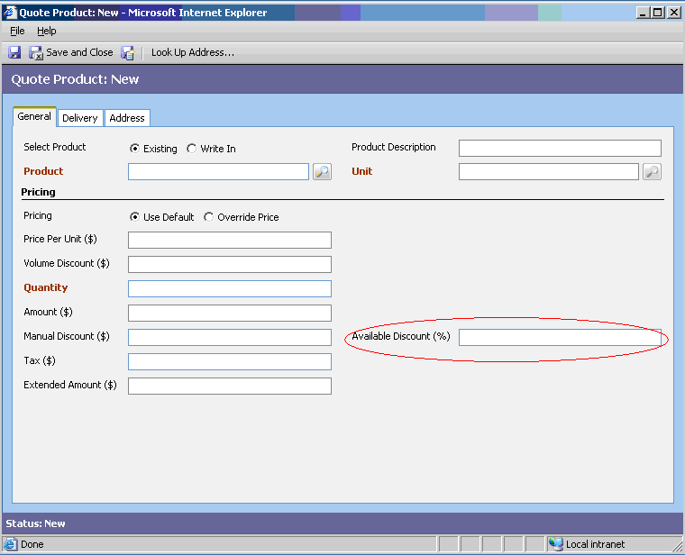
Figure 8 - Approximate view of Quote Product Form
Enable the OnChange event and add the following code:

// ___Discount Package 3.0___
var manualdiscountpercents = crmForm.all.new_manualdiscountpercents.value;
manualdiscountpercents =
((manualdiscountpercents == null)||(manualdiscountpercents.length == null))?
0:LocStringToFloat(manualdiscountpercents);
var baseamount =
crmForm.all.baseamount.value.replace(ORG_CURRENCY_SYMBOL,"");
baseamount = (baseamount.length == null)?0: LocStringToFloat(baseamount);

if(baseamount == 0)
{
alert(" Amount($) is not calculated yet. Click Save, then provide value for Discount(%) to recalculate Manual Discount($) !");
}
else if(manualdiscountpercents == 0)
{
alert(" You must provide a value for Discount(%) !");
}
else
crmForm.all.manualdiscountamount.DataValue =
manualdiscountpercents*baseamount /100;
Listing 10 – Script to add to Available Discount(%) field OnChange
- On the form, add a new “Additional fields” section, as shown on the below figure:

  - Add existing fields : new_parentaccount, new_ customergroup, new_productgroup
  - Add IFrames: IFrame_Account, IFrame_Quote, IFrame_Product with URLs starting with http://
  - Uncheck “restrict cross-frame scripting”
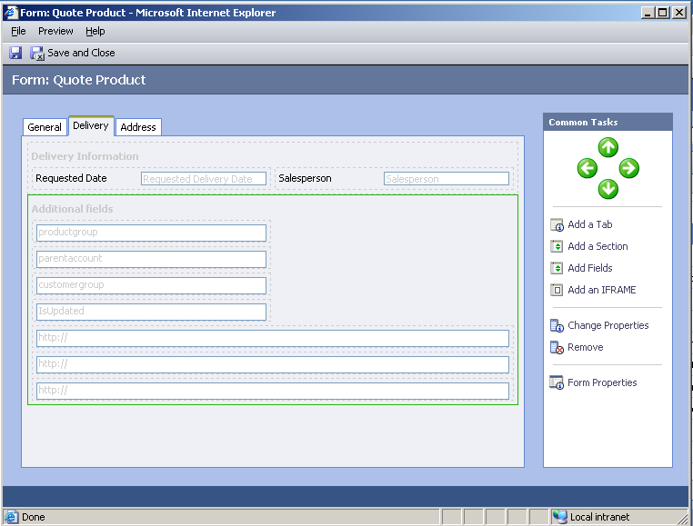
Figure 9 - Additional fields on Quote Product Form
- Save and publish the Quotedetail entity.

Configuration Customization

ISV Config
Add the following XML snippet to the isv.config.xml file (<your local disk>:\ Program Files\ Microsoft CRM\ CRMWeb \_Resources\isv.config.xml):

<Entity name="quote">
<ToolBar>
<Button Title="Header Discount..."
JavaScript='document.body.ShowLookUp();'
ToolTip="Info on Test" Icon="/_imgs/ico_18_1055.gif" />
</ToolBar>
</Entity>

<Entity name="quotedetail">
<ToolBar>
<Button Title="Lines Discount..."
JavaScript='document.body.ShowLookUp();'
ToolTip="Info on Test" Icon="/_imgs/ico_18_1055.gif" />
</ToolBar>
</Entity>
Listing 9.1 – XML snippet to add to ISV Config
Two buttons (Header Discount and Lines Discount) will appear on the Quote and Quote Product entity forms.

Web Config
Find section “appSettings” and change “ISVIntegration” value to “All”
<appSettings>
...
<add key="ISVIntegration" value ="All"/>
</appSettings >
Listing 10.2 – Changing "ISVIntegration" value of Web Config

Finalization
- Save and publish all entities
- Reopen the Microsoft CRM 3.0 system

Automatic Customization: Discount Package Installation Program

Preparation for Discount Package Automatic Setup
Note
To perform the installation steps below, you must log on to the system under the account with domain administrator permissions.
Copy the following files to one directory (or create the DiscountSetup folder):

- The installation files:

  - WinDiscounbtSetup.exe
  - CRM.dll

- The Customizations folder with files:

- new_entities_customization.xml;
- isv.config.xml;

- Folders:

- account(files: onLoad.txt)
- product(files: onLoad.txt)
- quote(files: onload.txt )
- quotedetail(files: onload.txt, onChange.txt)
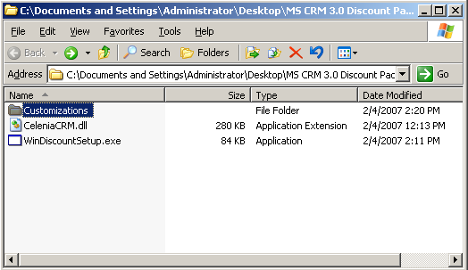
Figure 10 - Discount Package: Setup project file structure

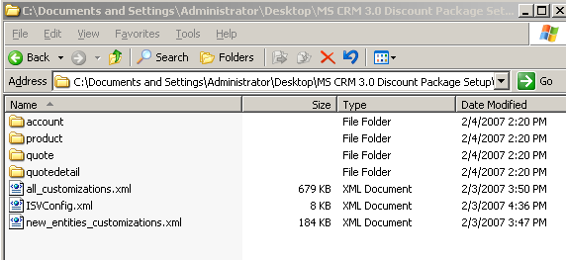
Figure 11 - Customization folder content

Description of CRM Discount Package Installation Program
Run WinDiscounbtSetup.exe:
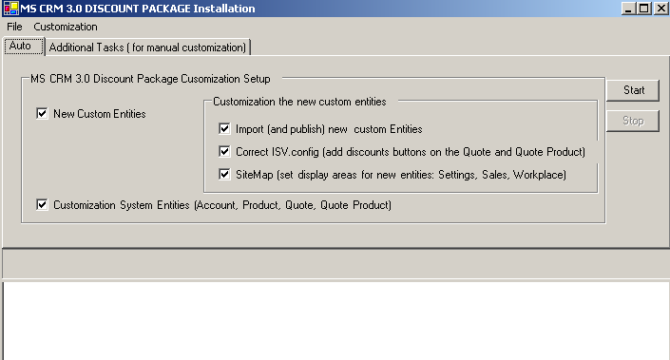
Figure 12 – CRM Discount Package installation program: Tab for auto installation
Two directions can be distinguished:

- Automatic (Auto tab): automatic installation of CRM Discount Project, which consists of such parts:

  - Customizations intended for new custom entities:

    - Auto import custom entities : CustomerDiscountGroup, ProductDiscountGroup, SalesLinesDiscount, SalesHeaderDiscount

    - ISV.config.xml customization (adding discount buttons on the Quote and Quote Product forms)

    - SiteMap.xml customization (display areas for new entities: Settings, Sales, Workplace)

  - Correct system entities (adding fields on the system entity forms, onLoad and OnChange events scripts, and post correct codes of custom entities in these scripts).

- Additional manual tasks, such as: view the customization file, or get a custom entity code.

Automatic Installation
For full installation, select all the check boxes on the Auto tab:

- Run the installation program (see 4.1 Preparation for Discount Package Automatic Setup and 4.2 Description of CRM Discount Package Installation Program)
- Click the Auto tab
- Check all the check boxes on the tab
- Click Start
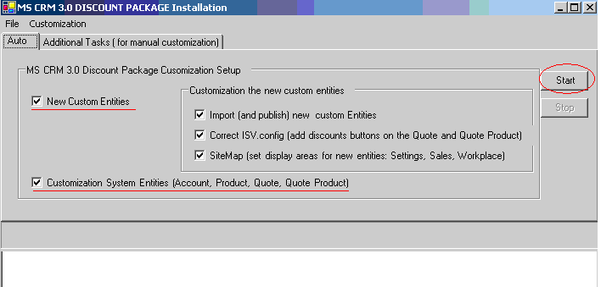
Figure 13 - CRM Discount Package installation program: Full auto setup
That will enable the Stop button and you will see progress and the active phase of the setup process.

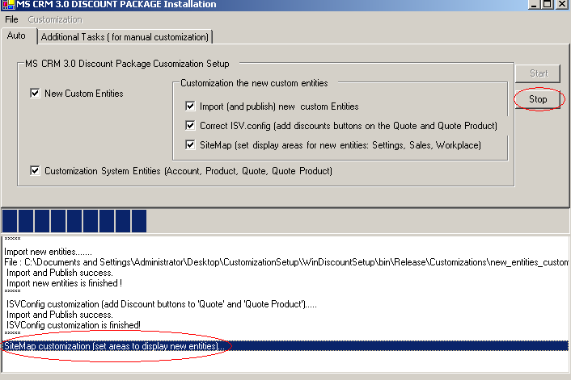
Figure 14 - CRM Discount Package installation program: Active phase setup of process

New Custom Entities Option
This type of customization has three phases:

- Auto-import and publish the new custom entities :

- CustomerDiscountGroup
- ProductDiscountGroup
- SalesLinesDiscount
- SalesHeaderDiscount

If these entities already exist in your Microsoft CRM 3.0 system, you can clear this check box.

- ISV.config.xml customization: code described in 3.2.1 ISV Config will be added to ISV.config.xml to create discount buttons on the Quote and Quote Product forms
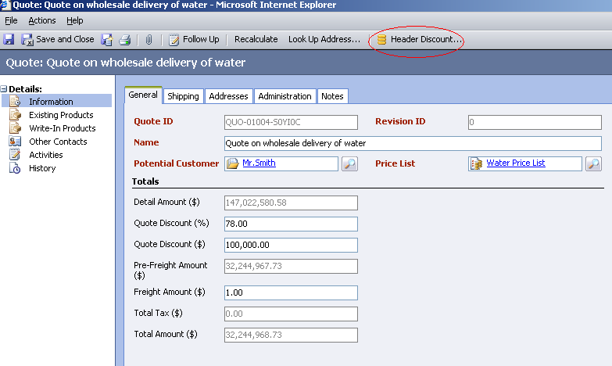
Figure 15 – CRM Discount Package installation program: Header Discount button (Quote)
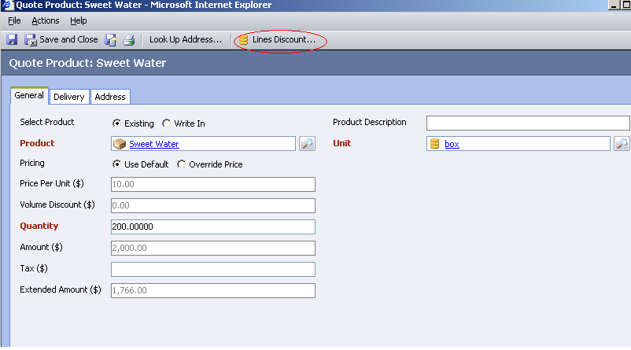
Figure 16 -CRM Discount Package installation program: Lines Discount button (Quote Product)
- SiteMap.xml customization (display areas for new entities: Settings, Sales, Workplace).

Customization System Entities Option
This item automates such phases:

- Adding additional fields on the forms(see 3.1 Customizations of System Entities)

- Adding client-side code (onLoad and onChange) to system entity forms

- Auto-correcting codes in system entity scripts (see 3.1.3 Quote and 3.1.4 Quote Product)

Additional Installation Tasks
The Additional Tasks tab is intended to facilitate a number of manual tasks.

View Customization Files
Select the View Customization Files option and click View to open the Customizations folder.
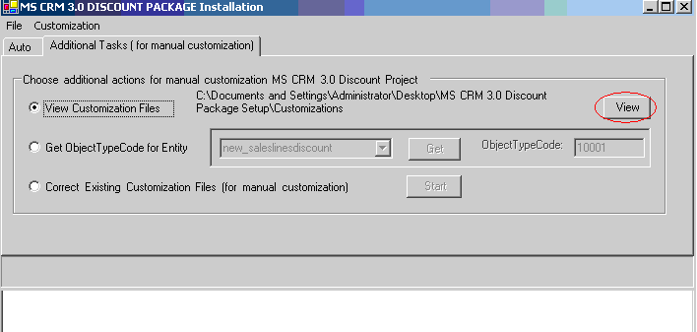
Figure 17 - CRM Discount Package installation program: Additional Tasks tab
After that, the Open File window will appear with the contents of the Customizations folder files.

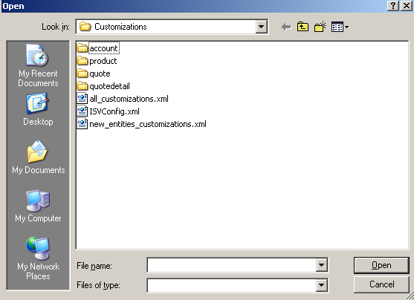
Figure 18 - CRM Discount Package setup project customizations files overview
Then go into one of the subfolders (for example, quotedetail), select a file (for example, onLoad.txt) and click Open.

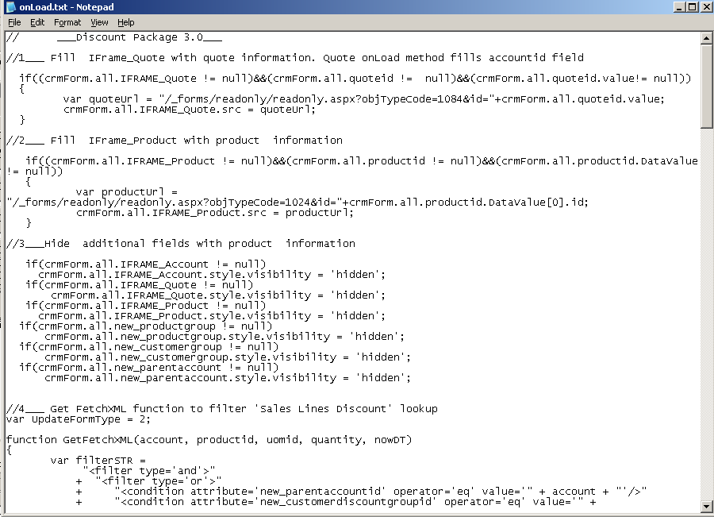
Figure 19 - CRM Discount Package installation program: Open customization file for Quote Product OnLoad event

Get ObjectTypesCode of Custom Entity
During the manual customization of system entities, it is necessary to detect ObjectTypesCodes of new custom entities (see 3.1.3 Quote and 3.1.4 Quote Product) and replace them in the form scripts.

The Get ObjectTypesCode for Entity option serves for these purposes.

Select the entity name (or enter it manually) and click Get to detect the code of the selected entity.
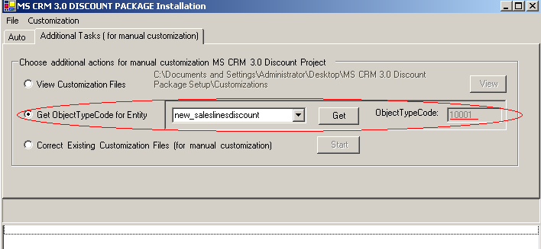
Figure 20 - CRM Discount Package installation program: Detect ObjectTypesCode of customizations files overview

Auto Correct customization files
There is another approach to correct the system entity customization scripts:

- Correct customization files in the Customizations folder.
- Use them for system entity customization as described above (see 3.1.3 Quote and 3.1.4 Quote Product).

For this, select the Correct Existing Customization Files option and click Start.
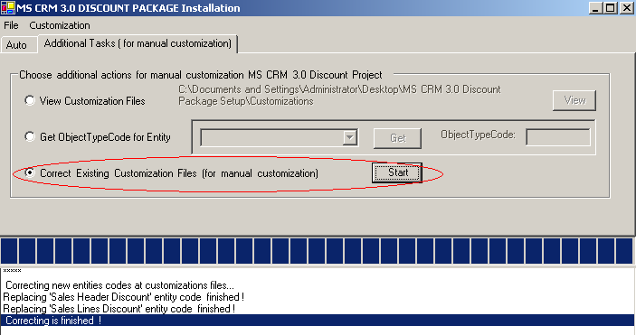
Figure 21 - CRM Discount Package installation program: Correct Customization Files
If the “Correcting finished !” message will appear in the log pane, the OnLoad.txt files will be prepared for use when adding to the forms in the respective subfolders (quote and quotedetail) in the system entity scripts folder (Customizations).

Post-Installation Verification
- Open your Microsoft CRM system. Click Settings, Customization, Customize Entities.

- In the Entities list:

  - Make sure that four custom entities of CRM Discount Package are present (see 2.1 Description of Custom Entities in Discount Package). If not, perform operations described in 2.2 Import New Custom Entities to Microsoft CRM 3.0 or in 4.2.1.1 New Custom Entities Option.

  - Make sure that the Settings, Sales, Workplace checkboxes are selected for each entity (see 2.2 Import New Custom Entities to Microsoft CRM 3.0)

- For a number of system entities (see 3.1 Customizations of System Entities):

  - Make sure the OnLoad event is enabled.

  - Make sure the specific client-side script is added.

- Make sure that the XML configuration snippet (as specified in 3.2.1 ISV Config) is added to ISV.config.

